COMP – 4920: Lecture Notes

# Lecture 2: Theoretical Underpinnings of Ethics

**The example of bumping into a car**

* You bump into a car while parking yours in an empty parking lot, the card owner is not there, what thoughts go through your head?
* Lots of things, but somewhere in your mind, there’s an ethical dimension to your thought process
  + Thoughts like “what would I like to happen if this happened to me?”
* Essentially, your thinking is focused on answering the question “What should I do?”

**A (maybe the) Hallmark of Ethical Thinking**

* The recognition that there are appropriate interests other than your own, that should act as constraints on unbridled pursuit of self-interest

**No. 1 Practical Problem of Moral Reasoning**

* One of the most important practical problems in matters of ethics is how you can turn an ethical problem into a non-ethical one
  + By that he means that it seems to be best to turn an ethical dilemma into a situation that is win-win
  + For example: Say Judy tells me something and makes me promise not to tell Sam, but I realize that Sam would really benefit from finding out. Should I tell him? There’s an ethical dilemma now, but if you tell Judy “look, he would not only like to know this but everybody would benefit from knowing it”. If she says you can tell him then everyone benefits and it’s not a moral problem anymore
* Practical reasoning can be made win-win, not ethical problems usually

**The four/five most Important Ethical Characteristics in People**

* Honesty
* Integrity
* Fairness
* Compassion (caring)
* Openness
* But what about when these things clash?
  + E.g. Your Aunt Betty wears an ugly hat and asks you what you think of it: Honesty vs. Compassion
* These values are the same across cultures, though some can prioritize things differently based on how they resolve conflict

**Relativism**

* Descriptive Relativism: the idea that values are different, relative to cultures, times, places, individuals, etc.
  + Dr. Cohen firmly believes this isn’t true
* But even if descriptive relativism is true, it doesn’t establish Normative Relativism:
  + That different views are all equally correct (people can have different values but that doesn’t mean they’re all correct)
  + That we oughtn’t to interfere or judge other cultures’ values

Note that what we just discussed changed the question from “What should I do?” to “What kind of person should I be?”. This later one used to be the primary concern long ago though both existed. Now we really think about both.

**Descriptive Ethics:** Investigates what people do, and what they think are the right things to do. “This is what they *do* think”.

* So it describes behavior
* Basically anthropology, sociology

**Prescriptive Ethics:** Reaches a view about what *ought* to be done, and how people *should* behave.

* Normative Ethics (principles) 🡪 Normative Issues 🡪 Casuistry, Moralizing
* Basically answers the question about what should be done

A moral judgment is one based on ethical reasoning (e.g. you think a guy is an immoral, selfish, despicable human being but it turns out you just hate his guts, that’s not a moral judgment)

* If you can’t explain your decision in terms of a moral principle then it is not a moral judgment
  + Ethical reasoning requires that you do this
* An example of a moral judgment

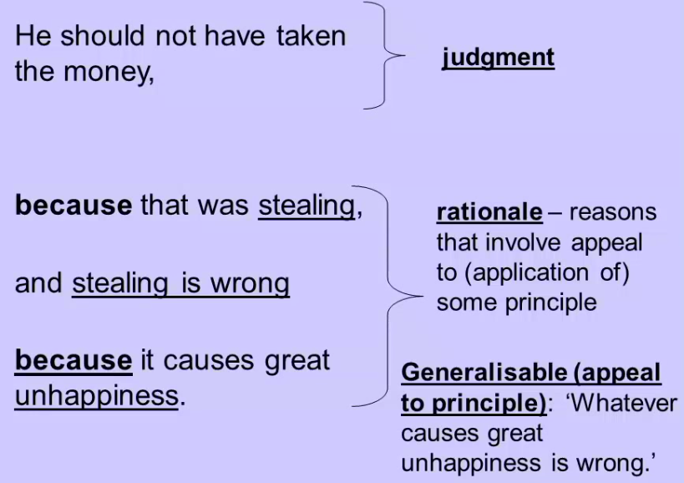

**What Makes Moral Reasoning so Difficult?**

* Here moral and ethical mean the same thing, as opposed to:
  + Prudential (looking after your own interest, can be health like visiting the dentist annually)
  + Political (you have a view but you think the appropriate way to settle the issue is to vote
  + Preference
  + Artistic

**Ethics**

* Ethical reasoning is focused with the top two parts of this chart:

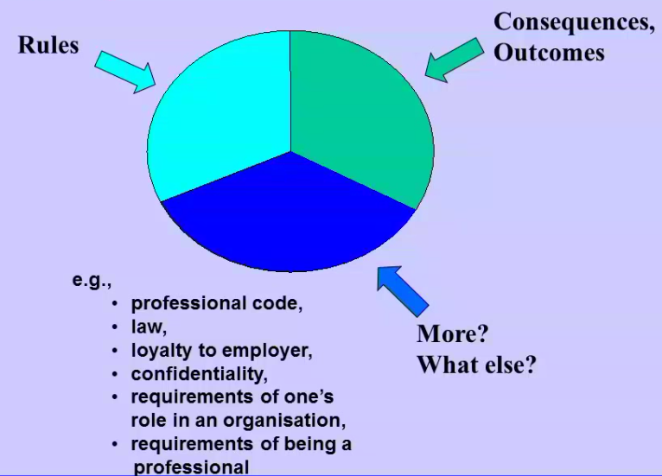

* Rules are things like the golden rule (“Do unto others as you would have done to you”) or “don’t like”, “don’t cheat”, etc.
* **The biggest difficulty in moral reasoning is when concern for the rules and concern for consequences clash**
  + There are no formulas for this
* This becomes even more complex when you consider the bottom part
* The top two represent your private morality, whereas the bottom is your public morality (role morality)
  + You might be in a role where you have obligations
  + E.g. You hear your lawyer colleague talk about something that the public should know about, but he has a duty to confidentiality
  + So it can be about what your role requires

**Different aspects of Ethics**

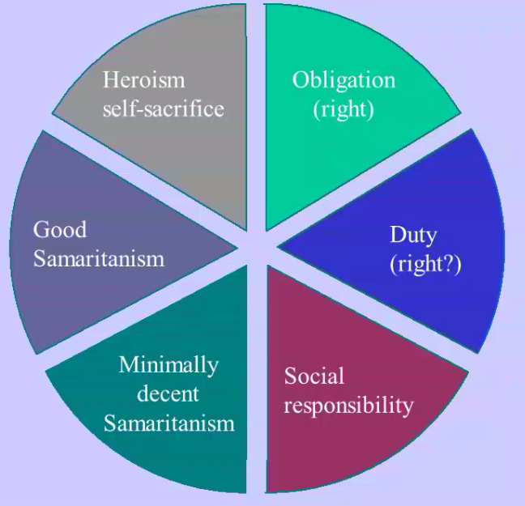

* **.**
  + ...
  + …
  + Heroism: Going above and beyond the call duty
* These are all moral things and they’re all different from each other
  + There is no order of priority of all these things
  + And there is nothing about them that says that one is more important than another

**What can we expect – and what can we demand – from moral reasoning and moral reasons?**

* A quote from Aristotle
  + He’s saying that you can provide good arguments but don’t expect scientific proof, just as you wouldn’t expect any from a rhetorician

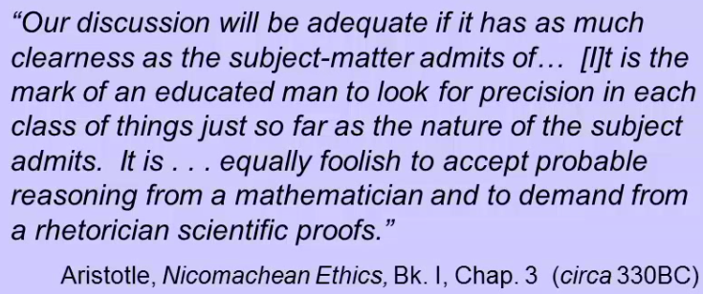

**Example: The Ford Pinto**

……

* Let’s look at what they did wrong or, rather, why it was wrong.
* For one thing, that they put it through cost benefit analysis
  + And the analysis itself may not make sense because what about things like reputation, which weren’t weighted in?
* **Light of day test:** How would you feel if what you just did was to appear on the front page of the Sydney Morning Herald tomorrow? Would you be comfortable with that?
* So what are some better ways to look at this than through cost-benefit analysis, reputational cost, or the light of day test?
* You could look at:
  + What would be fair?
  + What would be a reasonable expectation of a car-buyer?
  + Who should (knowingly) assume what risk?
* The previous metrics were more appealing because they were metrics, whereas these aren’t, but they’re what we should be looking at
  + *It’s not a matter of rules and formulas, it’s a matter of judgment*

**Professional life**

* In organizations and in professional life, these things go on:

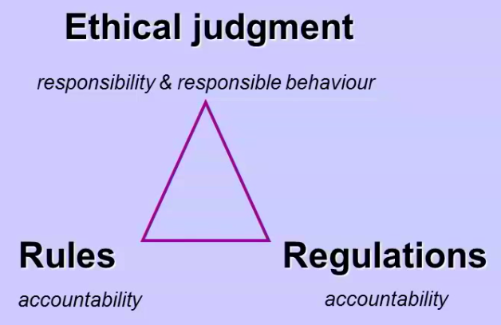

* Organizations have rules and regulations, both of which you are accountable for
* The top part is about responsibility, being a responsible employee, etc.
  + This is open to criticism, we must exercise our best judgement
* Companies these days (according to lecturer) have enforced the bottom two and not encouraged ethical judgment as much

**Accountability vs. Responsibility**

* Accountability offers/uses:
  + Historical tracks
  + Tick the box
  + Reveals liability
  + Directives (rules)
  + Emphasis on process, metrics and reporting
* Responsibility
  + Proactive
  + “Take responsibility for”
  + Judgment/discretion
  + Ethical empowerment
* Over the past 20 years companies have gone from practically no responsibility requirements to an overwhelming amount

**“What gets Measured gets Managed.”**

* This is actually pretty bad, it implies that things that aren’t measured don’t get managed and that those which can’t be measured should be neglected
* Is what we’re measuring really a reflection of what we’re concerned about?
  + E.g. Concerned about teaching well and we measure if students liked the course, not a good measure
  + Relevant to **concept validity**
* In some areas, is it necessary – and is it possible, to have generic/quantifiable criteria?
* If we can count it, can we really judge it?

**Concept Validity**

* Are our criterias measure what we’re actually trying to measure
* Some people argue that IQ testing doesn’t measure intelligence
  + Because it was originally designed to identify people who were mentally challenged

**The Kirkpatrick Model**

* To measure the effectiveness of workplace training
* **Level 1: Reaction**
  + Did the attendees like it? What were their reactions? How did they evaluate it?
* **Level 2: Learning**
  + Did the attendees learn anything?
* **Level 3: Behavior**
  + Did the training change the behavior of the attendees?
* **Level 4: Results**
  + Does the changed behavior have implications for business success?
* **Level 5: Return on Investment (ROI)**
  + In terms of business, was the training worth the costs?
* Most teaching institutions like universities don’t go beyond level 1

**Ethical Awareness**

1. Avoid moral negligence
   1. “Is there a moral dimension to the problem here?”
2. Avoid moral recklessness
   1. “Have I adequately addressed the moral concerns?
3. Avoid moral blindness/moral illiteracy
   1. “Have I identified all the moral areas of concern, and the moral values involved?”
   2. This is if you see an issue but don’t see the moral dilemma, or don’t see the problem at all
4. Exhibit moral competence
   1. Deal with the issue, displaying an awareness of its elements and facility with ethical concepts and tools, if there are any
   2. Being able to deal with the moral issues in a way that is credible

**Ethical Caution**

* Preventing, avoiding, minimizing the unethical
* **Precautionary principle**
  + If we don’t KNOW that an action is harmful, we must proceed as though it IS harmful – and act accordingly
  + If we don’t KNOW that there is no risk, we must proceed as though there IS risk – and act accordingly
* These may not be great ways to express it because it sounds like we’re saying “if you want to drive your car, don’t because it could be dangerous” but the idea is there
* Provide **‘safe exits’**
  + Where there is risk (maybe of actual harm, maybe of ethical wrongdoing), we should provide mechanisms for behaving/responding if that risk is realized
* Engage in **‘defensive driving’**
  + This is risk avoidance. Even if it would not be our fault if something untoward occurred, we can still take steps to best ensure that that untoward occurrence does not happen

**Whistleblowing**

* Internal
  + Reporting through channels
  + Doing an end run
* External
  + Going outside the organization
  + Regulator or other authorities
  + Public
* The lecturer thinks it isn’t the right thing to blow the whitsle because it comes at a huge risk for your self interest
  + “For 90% of people who blow the whistle, if you ask them 6 months later if they wish they hadn’t done it they say yes”

# Lecture 3: Moral Reasoning and Professional Ethics

The point of a lot of this lecture is to discuss ways to be morally aware, by knowing ethical theories that can help us deal with ethics competently.

**Normative Ethical Theories**

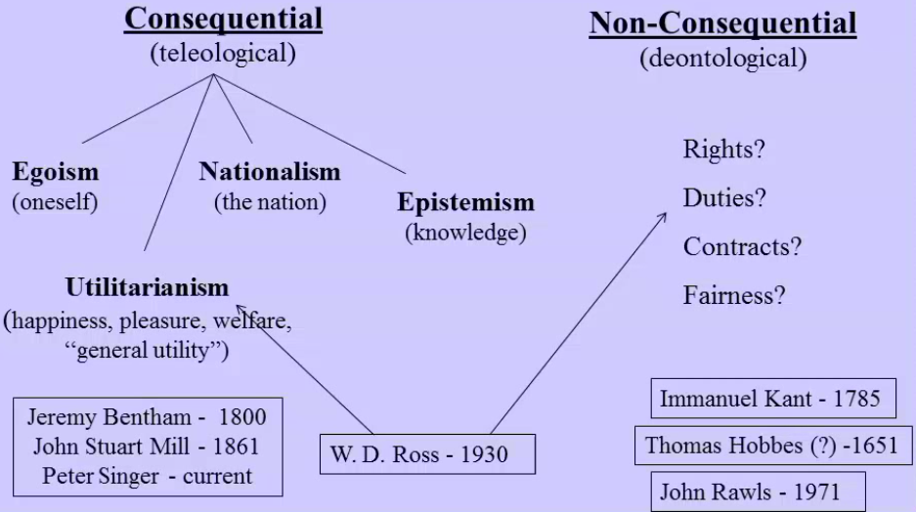

* The biggest difficulty is when concern for rules and concern for consequences clash
  + But the rules that you see may differ depending on your ethical theory
  + Sometimes it’s based on consequences (tiliological)
  + Sometimes it’s not based on consequences (deontological)
* Consequential views look to the future, will good be produced, forward looking
* Non-consequential look to the past or present, it’s right or wrong because I’m keeping a promise I made (past) or because it wouldn’t be “fair” (present)
* The three upper philosophies under consequential theories judge that something is right if it
  + Is good for oneself
  + Is good for the country
  + Advances knowledge
* Utilitarianism decides that an action is right if it produces utility (happiness, pleasure, accomplishement of desires, etc.)
  + You may measure this
  + John Stuart Mill
* Non-consequentialism is about if things are “right”, “did it respect somebody’s rights?”, “was it fair”, “is it in virtue of a contract”

**Immanuel Kant (1785)**

* Kant argues that ethics isn’t and can’t be what consequences are about
  + This is because consequences can be about luck or about a person’s nature
  + If I’m just naturally interested in helping people, does that make me moral? Well I can also type fast cause I have nimble fingers; do I get credit for that? No
* The only thing that is good without qualification is a good will
  + i.e. A will which wills well (does a good job willing)
  + You may be strong, but if you only use that to beat people up, that’s not ethical, so it’s about will
  + The good lies in the willing, not in the particular thing which was willed (“A will which wills well”)
* Anything that you think might be good, you can present a situation where it won’t be, but not so for having a will that wills well
* We make the principles according to which we will and if we’re strong enough we can act according to them

A test:

* Autonomy is what’s important
  + Aotnomous choice
  + Autonomous decision-making
  + Autonomous willing
* **Could what you are willing become a universal law?**
  + E.g. Promise keeping. Is it ok to break a promise in the hard case? (Is it possible to break a promise and be ethical?)
    - Promises are two way: I make a promise, and you have to believe it. If you don’t believe that I can do what I promise then I’m just uttering words
    - If we all accept the principle that says “it’s morally ok to break a promise in the hard case”, well when the hard case comes, you’ll never believe my promise, it’s self-destructive
* Promise-keeping is an example of what Kant calls a ‘**perfect duty**’: that is, it allows no latitude for inclination
  + In the case of making a promise, the duty is to keep it, full stop; no exceptions
* He also thinks we have a duty to develop our talents, but this has some leaway

**The categorical imperative – 5 formulations**

* First, understand this:
  + An imperative: “do this”, “do that”, “don’t do that”
  + Categorical means there’s no question, no ifs and buts, just do it
* A maxim is a general principle, that people operate according to
  + E.g. “whenever a friend asks me to do something, then if my calendar is clear I’ll do it”
  + E.g. “whenever someone offers me gobs of money to perform before an audience, I’ll do it”
  + E.g. Someone running to catch a bus, the maxim is that they think it’s worth their while to catch the bus, if we don’t see that then we can’t make sense of it

**The Categorical Imperative – 5 Formulation**

1. “*Act only according to that maxim by which you can at the same time will that it should become a universal law*” (i.e. if everyone were required to do it)
   1. A test: “Law of Nature”: “*Act as though the maxim your action were by your will to become a universal law of nature.*” – not a matter of choice, but more like gravity
2. “*Act so that you treat humanity, whether in your own person or in that of another, always as an end and never as a means only.”* – respect people’s personhood
3. … skipped in class
4. *…* skipped in class
5. (Principle of Autonomy) “*Never choose except in such a way that the maxims of the choice are comprehended in the same volition as a universal law.” ­*– you recognize that you are determining

* We have autonomy, we can decide on our principles and act upon them

Some random slide?

* Duty as the basic moral feature
* Good will
  + Not in terms of effects
* Good will 🡪 Duty
  + Agent autonomy
  + Morality not a matter of luck or accident
* Avoidance of hypocrisy
  + If I tell you I’m not a racist but I don’t associate with any other race than my own, I’m not a hypocrite, I just lied to you (because I told you that I’m not a racist even though I know I am)
  + If I think I’m not a racist, but I only vote for, hang out with, go in stores for people of my race, then I have a false belief about myself. There’s an inconsistency between what I believe about myself and how I actually behave
  + Also a hypocrite if you believe you’re acting according to a maxim but you’re not
* Not character

**Hypocrisy**

* A “practical” inconsistency between what a person believes about themselves, and how that person actually behaves
* Willing a maxim, and acting according to it
* False promise in the hard case ~= hypocrisy
* Maybe you actually believe about yourself that you’re acting according to a maxim (a general principle), but you’re not, in fact, acting that way

**John Stuart Mill (1861)**

* Mill said that whenever we’re doing something, we always have an end result in mind. There’s always something that we’re trying to accomplish, some consequence.
  + He says that talking about consequences is the only thing that makes sense the same way Kant says you being responsible for what you do and willing well are the only things that make sense
* When we engage in any action, we first have some idea of what we’re trying to accomplish
* A reasonable gauge, then, of rightness and wrongness would seem to be whether the means we’ve chosen to get there actually do the job
* In the most general sense, what we’re out to achieve is happiness.
  + There is no principle reason why our own happiness is preferable to anyone else’s
* Therefore “*actions are right in proportion as they tend to promote happiness; wrong as they tend to produce the reverse of happiness … “*
* “…… long quote from Mill about Kant……”
* Basis of morality
  + Anti-Kant
* Consequences are what matters
* Utilitarian principle
  + Note that utilitarianism is NOT “the greatest good for the greatest number”, it is a principle about the greatest good, period. It has nothing to do with distribution, it’s a principle about production. If it turns out that the way to maximize it is to distribute, then go ahead, but it’s not distributed because of the principle, it’s distributed because that’s what maximizes utility
* The calculation may be difficult, but so is it in math, science and elsewhere
  + Though it this case it may actually be a 100% impossible calculation
* But what about accidentally bringing happiness or sadness despite intentions? Mill doesn’t address that, he just says the calculations are difficult so yeah…
* So does utilitarianism focus on intentions (which seems too weak) or on what you actually deliver (which seems too strong)?
  + Is it about delivering the good or having your heart in the right place?
  + Mill doesn’t address that

**W.D. Ross (1930)**

* Ross argued that Utilitarianism involves too many calculations that it’s too complicated, that we shouldn’t have to do that…
* *Prima facie* duties
  + *Prima facie:* Things that you *ought* to be doing, in the aunt betty example you had two prima facies, making her feel pretty and telling her the truth
* You must (not me morally negligent) and see them, weigh them, and decide
* Essentially, he says that there are many things that impinge on us, we must take them into account. This is in opposition to utilitarianism which says that nothing matters but consequences
  + Kant said it wasn’t about consequences, just about the will
  + Ross says it’s about both, consequences and will, and other things

1. Duties resting on one’s own previous acts
   * Fidelity – resting on a promise
   * Reparation – resting on a previous wrongful act
2. Duties resting on others’ previous acts
   * gratitude
3. Duties resting on the possible inappropriate distribution of pleasure or happiness
4. Duties resting on the possibility of our being able to improve people’s conditions with respect to virtue or intelligence or pleasure
   * Beneficence
5. Duties resting on the possibility of our being able to improve our own condition with respect to virtue or intelligence
   * Self-improvement
6. Duties resting on the recognition that there is a distinction between helping and not harming
   * Not – maleficence – More stringent than duty of beneficence

**Moral pluralism**

* “*There is no single moral theory or principle that should be accepted as preferable to others. There are different, diverse, and even mutually inconsistent ethical positions that should be recognized; and there is not necessarily any single moral principle or set of principles that everyone should accept”*

**Relativism:**

* Values are different. They are relative to, for example, cultures, times, places, individuals
* Descriptive relativism: A matter of fact – it’s what goes on, culture-to-culture
* Normal relativism:
  + The different views are all equally correct
  + We oughtn’t to interfere or judge other cultures’ values

**Contractarianism**

* Thomas Hobbes (1651)
  + Without society, there is “*continual fear and danger of violent death; and the life of man is solitary, poor, nasty, brutish, and short”*
  + Without society, there is no ethics – just as there is no ethics among animals
  + Which requires that there be a contract among the parties concerned
* So we agree to give our power to people so that they can do the hitting (and getting hit) if needed

**John Ralws, *A Theory of Justice* (1971)**

* I think the idea here is that, for all intents and purposes, we are equal. Going from that basis, say you were just going to be assigned a role in society, what principles would you agree upon (to protect individuals)?
* The ‘original position’ – people are free and equal
  + What principles would people agree upon? Principles *‘that rational and free persons concerned to further their own interests would accept in an initial position of equality as defining the fundamentals of their association*’
* How can we figure out what these principles are?
* Operating from behind a *“****veil of ignorance****”*: *‘no one knows his place in society, his class position or social status, nor does anyone know his fortune in the distribution of natural assets and abilities, his intelligence, strength, and the like’*
* From this position, what principles would people agree on?
  + You would basically adopt principles that would protect you if you were assigned a position by your worst enemy

… skipped a slide in class …

**Strategies (from game theory):**

* Minimax – minimize your maximum loss (Rawls thinks this is *the* rational strategy for accepting a political setup)
* Maximax – Maximise your maximum gain
* Maximin – Maximise your minimum growth
* We can figure these principles out!

**Procedural Justice**

* If you engage in a procedure, it may be just or unjust:
  + Perfect procedural justice – you know what would be a just outcome, and there’s a procedure that will guarantee it (e.g. cutting a pie for 8 people, get the person who cuts the cake to take the last piece)
  + Imperfect procedural justice – You know what would be a just outcome, and although there’s no procedure to guarantee it, you can get a procedure that gets as close as you can get to it (e.g. criminal justice system, we can’t guarantee that non-guilty people won’t be convicted and vice versa)
  + Pure procedural justice – the justice of the procedure doesn’t depend on its producing any particular outcome. The outcome will be just if the procedure itself is just (e.g. flipping a coin)

**Virtual Ethics**

* Human Excellence
* Virtuousness- exhibiting the virtues

**Plato (*circa* 380BC)**

* Virtues: those things that enable humans to function well as humans
  + Virtues apply to everything, not just humans
  + Function of a knife is to cut. A sharp edge allows it to perform this function well. So, a sharp edge is a virtue of a knife
* What are particularly human functions?
  + Virtues are courage, wisdom, temperance, justice
* **Virtues are internal – not interpersonal as other ethics state (e.g. recognizing that there are interests other than your own**
* Good person
* If you have your internal stuff in order, the external stuff will take care of itself

**Aristotle (*circa 330BC)***

* Question: “What’s IT all about anyway?”
* Answer: Happiness
* Aristotle spends most of his book explaining what happiness is
* What does happiness amount to, and how do we get to it – **what are the characteristics we should develop in ourselves so as to arrive at happiness**?
* Whatever these characteristics are, they are “human virtues”. Consider the types of things that humans do, and where they (we) find happiness; and then consider what is involved in doing them well or badly: these will be the corresponding virtues and vices.
  + Moral virtues – concerned with “doing things”
  + Intellectual virtues – concerned with “thinking”
* Aristotle also spoke of the “**golden mean**”:
  + All virtues are concerned with feelings: the virtue is a mean between feeling too much and feeling too little
  + E.g. courage is the virtue concerned with the appropriate feelings of fear and confidence, it is a mean between too little fear (rashness) and too much fear (cowardice)

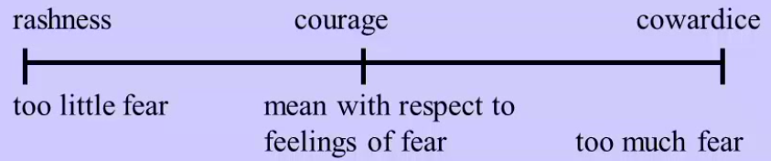

* The reason he focuses on happiness is that, if you keep asking someone about WHY they do something, eventually their answer will be “because it makes me happy”
  + Then you can ask “why do you think that will make you happy?” but it’s not appropriate to ask “why do you want to be happy?” That’s just self – evident according to Aristotle
* Degree of precision: …

**Exception which proves the rule**

* Proves means test – you have a general principle the’s supposed to cover all cases but a case puts the rule into question
  + The out come is that yes the rule is the cae, but this is an exception
* “If you disagree with a view but can see it as reasonable, then you ought to just let go”
  + This isn’t agreeing to disagreeing

**Reflective Equilibrium**

* Moral Principles 🡨🡪 Ground level intuitive judgment
* The standard approach is that you believe in one moral theory and walk about your life armed with it, so when a situation comes you use it to decide what to do and act
  + Tis is top down (moral to ground level)
* But sometimes the moral principles are not paramount, you have a gut feeling that is just stronger than what the principle says
* How do you decide which principles to use?
* **Exception which proves the rule**
  + You have a principle which is supposed to cover all cases but this one case you come across puts it into question
* Example of Dr. Cohen’s graduate classmate who failed one of the four main exams twice and was supposed to get kicked out but wasn’t because… he was a sharp guy?
  + So they basically made an exception
* **Counterexample:** A counterexample proves that a principle is wrong
* **Anomaly:** An unusual case that doesn’t make us reject the theory

**A hierarchy (William Frankena)**

* This is spoken about by doctors, police, etc. It is an order of priorities

1. Don’t inflict harm
2. Prevent harm
3. Remove harm
4. Do good

**Dirty Hands**

* Dirty hands is a situation where even if you’re doing the right thing, it comes at a moral cost
* You’re out in the jungle and this nasty guy on a firing squad is about to kill 12 people
* He gives you the option of taking the gun and killing one of the 12 people to save the rest (you can’t kill him)
* You choose the second option kill one person, the mom finds out comes and tells you you killed her son, you reaction may be
* **Expression of sympathy** (you didn’t do anything wrong)
  + “I’m sorry about what happened to you”
  + “I’m sorry for your loss”
* **Apology** (you did do something wrong)
  + “I’m sorry”
  + “I’m sorry for what I did to you”
* Dirty hands is where what you’re thinking the bottom one (apology)
  + Even though you did the right thing there is *an untoward moral remainder*
* It’s not “*damned if you do damned if you don’t*” but rather “*damned if you do, more damned if you don’t”*

**The trolley cart problem thingy**

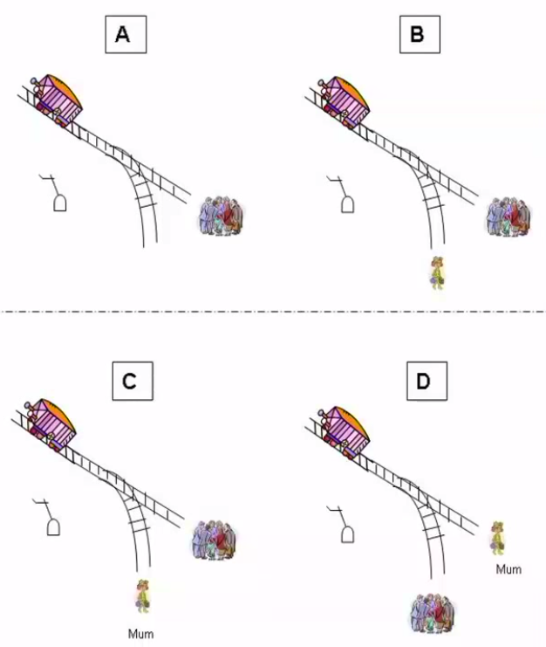

* **Agency:** Doing something vs. allowing something to happen

# Lecture 4: Legal Perspectives on the Software Industry

## Outline

* Strange bedfellows
* Legal system
* Liability (even if you’re liable, will anything happen?)
* Software development – immature?
  + Abuse of market power by companies like Google, etc,
* Examples

## Software, Law and Ethics

* Strange bedfellows: ‘rules’ are different
  + They’re not hard and concrete, but are soft and sloppy
  + Which is frustrating for engineers and computer scientists because something doesn’t always mean what it seems to mean
  + Yet it is still rigorous, just a different approach to logic
* How the law is made, and how it works
* Differing principles and standards
* ‘Rules of Law’, Natural Justice

## What shapes the law?

* Ongoing struggle between interests
* There’s a big range of influence on the law, you can have
  + Commercial reality (is something impossible? Such as the *internet filter*)
  + Technical reality
  + Public standards
  + International effects (indirect)
    - There are different levels of legal regulations, here we are in the local “Randwick council” or something like that, in the state level of NSW (for defamation law), and of Australian Commonwealth law
    - We’re not subject to US law or European law here
* Spoke about the US’s authorization to spend unlimited amounts of money on lobbying because then the poorer companies and people can’t compete

## Features of the Legal System

* Main divide: Criminal 🡨🡪 The rest (civil)
* Criminal
  + Launched by state, trial, conviction or acquittal
  + Criminal cases are launched by the government (state of country - federal - depending on severity) because it’s their duty to protect you
  + The head of state in Australia is the British crown, so they’re the ones launching the case
* Civil
  + If someone breaks a contract, that’s not the government’s business, so you launch it (for things like defamation)
  + Sued by other party, damages, restitution (“you caused this state, you need to contribute to the resolution”, “you permanently prevented me from getting a job as a programmer, give me $10 million”)
* Sources
  + **Statutes** (‘Laws’) set rules, **Cases** interpret (precedent)
    - In Common law countries, the importance of previous cases and resolutions is very high (as opposed to the law itself)
    - In countries that follow the Roman Law more (like Europe), precedents aren’t as important
  + **Jurisdiction:** which laws and courts apply wherever? AU? US? EU?
    - Example of the Joseph Gutnick vs. Dow Jones, Gutnick sued Dow Jones (based in New York) from Melbourne over articles they wrote and spread from the internet. The Victoria supreme court rule that the case was valid since the defamation happens when the articles are read, not when they are published.
    - Other example, the Australian Consumer Law which is pretty amazing because when you sign up for Adobe products or whatever, in the terms of agreement there’s a section that says that these rules don’t override whatever Australian rules apply (the ACL is about being fair, transparent, etc.)
  + **Contract –** private laws?
  + Codes, ‘Code’, convention
* Obligations: from Statutes and Contracts
* Everything is arguable, no right answer – reflexive
  + A judge with the right authority can go back on a previous decision and go against it
  + E.g. some Australian government organization thing tried to pass the Australian card or whatever and then disguise it as not an ID card but rather an access card and eventually not doing it even though they could have because it was too politically risky

## Three Wings of Government

* **Executive** (“The government”)
  + Includes agencies and departments, police, welfare departments, ministers, politicians
* **Legislature**
  + In Australia, it is composed of the Senate and the House of Representatives (one member for each small place around the country), if one party has the majority, they get to form the government, if they have the majority in the Senate as well, they can pass whatever laws they like
  + In the current government, there’s a balance so close that it just takes one vote to switch
* **Judiciary**
  + It’s the judges, who take decisions on case of disputes over the law

|  |  |  |
| --- | --- | --- |
|  | **Example** | **Function** |
| **Statutes** | ‘Laws’ or Acts: *Copyright Act 1968* | Set general rules, in a jurisdiction |
| **Legislature** | NSW Parliament | Listen to submissions, change laws |
| **Codes** | ASMRO Privacy Code | Industry-specific clarification of general law |
| **Jurisdiction** | NSW, Cth | Whose laws and courts apply? |
| **Court Cases** | *R v Usmamov* | Interpret laws in a dispute instance |
| **Precedent** | Case on same point | Critical in cases: must follow past |
| **Contracts** | Facebook terms | Private agreement on terms |
| **Norms, Conventions** | Right to free speech | De facto constraints |
| **‘Code’ (Lessig)** | DRM | May prevent or allow outside law |

* Codes are quite good for companies but bad for customers
  + They’re usually not clear, it’s a mess: which ones are in effect, which ones apply, which are mandatory or optional, which have an enforcement mechanism, etc.
* *R v Usmanov* was the case of the guy posting revenge porn images on Facebook, the original penalty was 12 months in jail, which he appealed to 6 months in jail, but some more was added because Usmanov and the lawyer didn’t seem to agree that they had done something wrong

## What matters?

* Breaking the law? Liability
  + Much of downloading of things on the internet is actually illegal…
* Getting caught? Enforcement
  + … but what you’re thinking is that you won’t get caught, so the enforcement level is low
  + And if the police shows up in the middle of the night to arrest you, you can’t complain, especially if your case is serious (child pornography, etc.)
* Losing your job? Professional
* Losing self-respect? Ethics
  + If you’re a software developer for example and make something that harms a lot of people but they can’t get back at you because they don’t know who you are and the company doesn’t say because you made them profit, there’s an ethical concern here
* Or just building crap? Reputation
  + If you create a bad product or do something that isn’t necessarily illegal but may be unethical and people start pointing the finger, that’s a concern

## Rule of Law

* You might care more about it if you’re in a country without it (if there’s no separation of powers for example and the political leader tells the judges to find you guilty)
  + Talked about Trump, who seems to think he can do whatever he wants (e.g. sack the FBI director, judges, etc.)
* No-one is above the law
* ‘Separation of powers’ (3 wings)
* Principles of ‘Natural Justice’
* Decision of a court is binding
* Statutes interpreted by known principles
  + In a country that is corrupt, this is also a problem as you don’t know if the judges have been bribed
* Interests and arguments taken into account and balanced
  + Example of the majority vs the minority, so if the majority is heterosexual, do they get the right to prevent things for the minority, which is homosexual?
* Restraint on arbitrary power (king, Trump)
* If you don’t like it, change the law (legisl.)
  + If a law is really bad and widely hated, you might be able to do something about it

## ‘Natural Justice’ – Fairness

Rights to:

* Know the case against you (evidence, logic)
  + If your case and punishments are very serious (e.g. death penalty), then you get all the benefits awarded to you, so the state will pay for your case, etc.
* Make case, be heard before decision
  + E.g. of the guy at the nazi march in Charlottesville
* Test and bring evidence
  + If you argue against a claim or accusation, you need evidence or a basis for your counter
* Impartiality, no bias, not corrupt
  + If a judge just says “I hate you young white guys with your nazi flags”, then he may be set aside with another more impartial judge asked to work on the case
* Decision only on evidence and law
  + The decision should be based on evidence and the law, not on opinion, etc.
* Procedural review (appeal)
  + If you disagree with the decision or think the judge is biased, the wrong rule was applied, etc. You can make an appeal

## ‘Natural Justice’ – Tech Fail?

Examples: App store or Facebook

* You basically submit your app and they deny it if they want to
* Don’t know rules, case against you?
* Don’t get heard before decision?
* Can’t test and bring evidence?
* Partiality, bias, corrupt influence?
* Decision on unknown criteria, fact?
  + Did you get a reason for which your app was denied? How was it decided?
* No procedural review (appeal)?

Private, arbitrary: where to from here?

* If things are made difficult for you because of the decision, can you appeal?

## Anti-trust: Abuse of Monopoly

* Competition policy
* Monopoly power
  + The economist will say this is bad because the monopolize can decide on the price himself
  + You don’t need a full monopoly, some companies have near monopolies or a lot of power
* Old example: *MS v DoJ re Netscape*
  + MS is Microsoft, the case was saying that MS used their monopoly of operating systems to squash Netscape by preventing it from easily get on MS
  + This was a long case that eventually Netscape won I think
* New example: Google v EU
  + EU says google is misusing its search monopoly from showing competitors, particularly small European companies from showing
  + Google has spent a lot of money on lobbying and “infiltrated” many parts of the US, Australian and other governments to prevent trouble
* Political involvement
* Practical significance
* Damage to competitors, lock out
* *Consumer and Competition act* in AU
  + Competition is good for consumers, monopolies are bad for consumers, competitors, etc.

## Anti-trust /2

* ‘Internet firms face a global backlash’

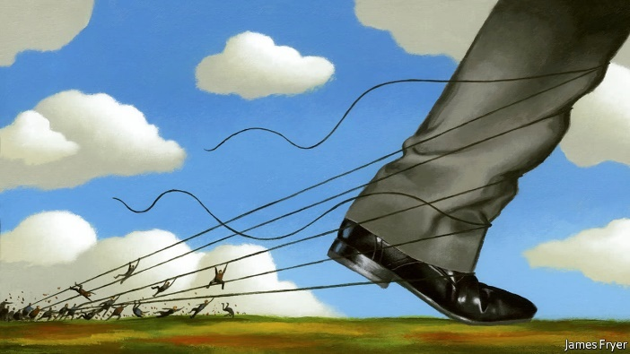

* + Article: <https://www.economist.com/news/international/21726072-though-big-tech-firms-are-thriving-they-are-facing-more-scrutiny-ever-internet-firms>
  + The article is about how large tech firms, which used to run quite free over the internet, are now being regulated more and more to prevent extremist posts and what not
    - Examples include China looking into Apple’s providing of VPN to bypass it’s censorship, etc.

Schrems case – ‘Safe Harbor’ fail

* The case of Max Schrems who files complaints and a lawsuit against Facebook for collecting data on him (and users in general) that they sent back to the US as part of the PRISM (mass surveillance) program
* The European Comission agreed on the “Safe Harbour” in 2012 or so, which said that the data was held in the US, where you have no rights as a European but if the company holding the data has a policy about protecting privacy then it’s ok
  + The European Court of Justice ruled, however, that it’s not legal, so the “Safe Harbour” isn’t in fact legal
  + There was a counter reaction which caused set up of the “Privacy Shield”, set up by Max Schrem, who said that it doesn’t fix the issue
  + So there’s a crisis right now challenging Facebook’s right to transfer data

## Crypto back doors & IT Security

* The Australian government proposed (idk when) that back doors be put into IT security tools around encryption
  + It seems that no one knows what exactly they want and why they need it since there are already a lot of policies that give it access to data
* Context: hacks and breaches of data are now “out of control”
  + No one now can truthfully say that they can protect your data
  + Example of the Office of Public Management who lost records of 20 million military officials, undercover officials etc. and who couldn’t protect them
  + Edward Snowden releasing data about the NSA
  + Promises of IT security now are almost not credible
* Fixya ransomware: stolen weaponized NSA exploit
  + Bruce Schneier now talks about data as being a toxic asset rather than a good thing, the more of it you have, the greater your problems are
* Data at rest example: San Bernadino iPhone 2016
  + Huge struggle between Apple and US department of Justice who asked to backdoor it
  + Apple did not want to create a backdoor, they designed the phone so that even they couldn’t break into it if they try
  + IN the end they used an Israeli hacking service to break into it
  + They refused because they don’t think that no one will be able to crack it, in which case it won’t be safe anymore
  + Apple refused to create backdoored iOS variant
* Data in transit example: HTTPS, MITM
* Cisco routers tampered? Escrow keys
  + Came out of Snowden revelations
* Standards example: NIST elliptic curve compromise
* NSA insisted on a flawed standard being put into <something> so that they could break into it
  + IT security profession lost trust, weakened for all
  + Now AU gov proposal to do <something> to require weak encryption model. No draft, no target

## Crypto back doors /2

* The concern is about how much we gain from back doors vs what the risks are and what we could loose
  + Now the thought it that all this is probably a crude political motive to try and make it seem like a big win against counter terrorism efforts
  + Suggests critics may approach laterally
  + Pollies: Need to declare a win, whatever means
* Example: ‘Filter’: Interpol list no relation to plan
* Critics: can they offer a win without the harm?
* Here the focus is on how lobbyists can attempt to divert this into something more pragmatic
  + E.g. Data Retention law, 29 changes proposed by a bunch of critics where just slid in to the data retention plan
  + The government and Australian Labor Party just agreed with it because it seemed to do something but they didn’t really understand it
  + These changes could have been due to foreign influence (which wasn’t the case but could have been)
  + Behind closed doors?
  + Opaque to public policy?
  + Influence of foreign motives?
  + Role of IT experts, industry, users?

---------------------------------------------

## People – Human Diversity

* Google bro memo – author = alt-right hero?
  + The memo was about a manager at google who sent out a memo saying that the diversity programs google is running are not helping for a number of reasons, one being that men and women are intrinsically different
  + Women are more sociable better at interpersonal relationships and communication whereas men are more driven and seek authority positions, in part because society places a large emphasis on the importance of being in a position of power as a man
* “Use of data to sledge diversity – seems plausible”
* Critique by Stanford CompSci lecturer Cynthia Lee:
  + ‘I’m a woman in computer science. Let me ladysplain the Google memo to you.’
* Misuse of stats, omission of critical social factors
* Failure to deal with the non-‘average’ Google
  + Ms. Lee talks about how Google isn’t “average”, there’s a different demographic that also has impacts
* Memo author sacked, complains free speech’
  + No free speech law in Australia, nor privacy
  + There’s a tiny free speech law about who you vote for but that’s it, so the free speech argument would not hold in Australia
  + In US, 1st Amendment is there to protect free speech
    - But this law says that the government isn’t allowed to pass laws that prevent free speech, religious freedom, etc.
    - It doesn’t protect you from other people reacting to what you say, it doesn’t protect you from private entities withdrawing their providing of services for you
    - So this isn’t a case of free speech impediment, only of the societal ideal idea of free speech
  + Free speech isn’t a right all the time, not if the consequences are serious (e.g. yelling fire in a crowded theater causing people to rush and get trampled)
  + E.g. Facebook videos posted of assassinations live and people imitated it, so free speech doesn’t apply in that case

## Big Data, predictive analytics

* Created by very smart people, hostile to regulations
  + “move fast, break things, etc.” which works well for software by sweeping away bureaucracy which wastes time, etc.
* Created by regulation-hostile ‘disruptors’ Goog/FB
* Tolerant of worst data – currency, relevance, completeness, accuracy, lawfulness
* Fine for low impact ad targeting
* Intolerable for serious matters: humans facing discrimination, targeting, adverse tagging?
  + Often you can’t undo those effects (like the guy at the Nazi march), maybe some systems weren’t designed to be fair, like add targeting, in those cases it’s not important but it is for things like drone targeting

## Big Data, predictive analytics /2

* Is it designed for algorithmic transparency?
  + The logic of the decision can be adjusted and made visible, the program can be made to ask a question if there’s a conflict
* Legal logic, evidence visible – ‘case against you’?
* Claim: humans can’t understand data or rules
  + For things like Machine Learning
* But is this by design?
* Judges, and human common sense, insist
* Can’t identify “spurious correlations”
  + Shows graphical correlations of things that don’t have anything to do with each other
  + Correlation doesn’t mean causation
  + Recently, Google’s algorithms was able to establish faster than the CDC and other medical bodies if an influenza epidemic was happening
    - So the criticism is now that these things are useless in comparison to Machine Learning, but then it stopped working, it was a spurious relationship that only happened to match at the start
* ‘Construct validity’?
* Discrimination intrinsic
  + The data doesn’t show some things, for example some neighborhoods have more officers, so more criminal cases are reported simply because more are caught, but on data it just seems like more crime is happening there
  + Is it a reasonable sample though? Discrimination comes out of this that isn’t always accurate

## ‘Open Data’

* This is the idea that a company or government holds data, and they release it to be transparen
  + Fine if no personal data source
  + Normally personal info is only released as aggregate, ‘anonymised’
  + The point is that you’re not identified from it
  + Move to release ‘de-identified’ unit data
  + Obfuscation, omission of fields, perturbation
* ‘differential privacy’
* But recent tech work by NICTA suggests this protection inevitably declines over time
  + Let a Machine Learning algorithm loose on this that was able to identify some people
* What is the slope? When will it fail
* No protections, audit
* Scary?

# Lecture 5: Employment Conditions and Contracts

**THIS LECTURE DOES NOT NEED A SUBMITTED SUMMARY**

* Only 20%~30% of job opportunities are ever advertised
  + The rest are part of the secret job market
* You get those opportunities by networking
* Networking effectively is building relationships with other people in your industry
  + Your peers already form a basic network
  + They’re a foundation for ti

**National Employment Standards 2010**

* 38 hour work week
* 1 + 1 year parental leave
* Flexible work week
* If you’re ever fired from your job, you need 4 weeks notice
* If your job ever becomes non-necessary (redundancy), you get a short payment until you find another opportunity

**Professional Employees award 2010**

* Minimum Wage: $47,103.24

**Probation:** Time period when you start during which you figure out if the employment is good for you

**Performance Review:**

# Lecture 6: Intellectual Property and Software Patents

## Software Development

* Testing
* Debugging
* Deployment
* Maintenance
* **Intellectual property**
* Design
* Market Research

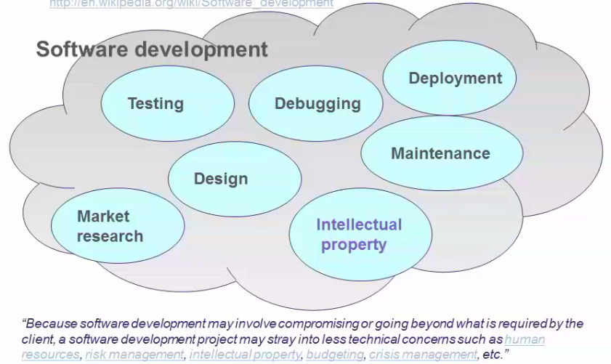

## Overview

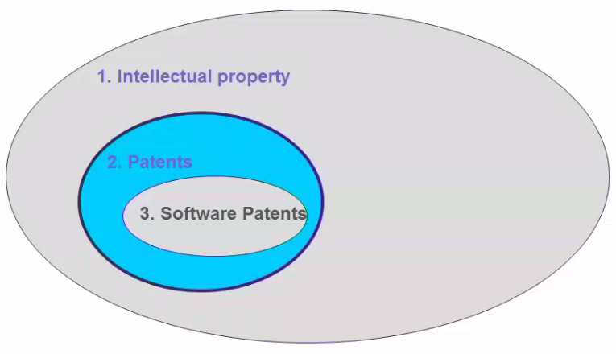

## Intellectual Property

* Types of IP
  + Trademarks
  + Patent
  + Copyright
  + Trade Secret
  + Registered Design

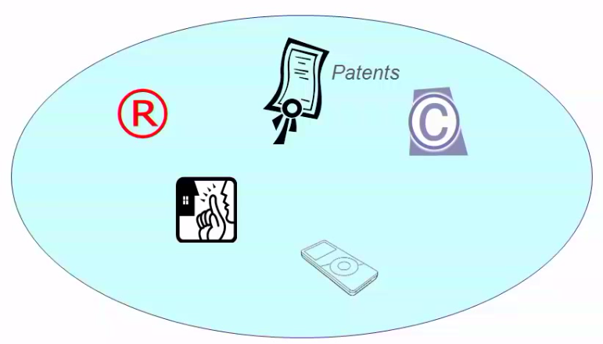

## How do the different forms of IP differ?

* Duration
* How to acquire
* How to enforce

## Patents

* Protect **functionality**, usually for up to 20 years (some are shorter, e.g. innovation patents last 7 years in Aust)
* Basic requirements to acquire:
  + New
  + Non-obvious
  + Eligible subject matter (Is it patentable? General concern: Is software patentable or not?)
* Basic requirements to enforce:
  + Falls within the patent
* A patent is a legal document, it defines your invention, your turf. If someone else does something within that, then it’s an infringement
  + You can file a claim

## Registered Designs

* A form of IP to protect the **appearance** for around 10-25 years
* Basic requirements to acquire
  + Not identical or substantially similar
* Basic requirements to engorce
  + Identical or substantially similar
* These protect the design of something, not the functionality
* You might be able to get a registered design on a User Interface
  + This isn’t tested in court yet so no one really knows how that would work
  + But people have filed for registered designs on UIs

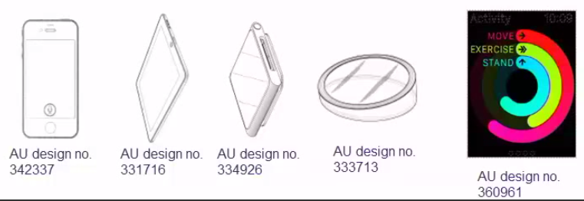

## Trade Marks

* Protects **brands** indefinitely!
* A sign capable of distinguishing a trader’s goods/services
  + Textual (Red Hat®)
  + Device (apple logo)
  + Can protect sounds as well (e.g. Five tone progression of notes DbDbGbDbAb, which is the Intel startup noise)
  + There’s a trademark on the word Coca-Cola and even on the shape of the coke bottle

## Copyright

* Protects **expression of an idea** … until death + 70 years
* Basic requirements to acquire:
  + No registration required (You put your idea on paper or a material form, and you have a copyright)
  + Original work upon material form
  + Literary, artistic, musical, performance… includes computer programs (in C++, Fortran, etc.)
* Basic requirements to enforce (in contrast to patents)
  + Substantial copying (same idea is ok but lots of copy is not)
    - In comparison, for a patent, even if someone comes up with an idea independently, it’s an infringement for them to use it
  + Will not protect against independent creation/function

## Trade Secrets

* Protect **confidential information** for … as long as you can
  + E.g. Coca-cola formula, KFC recipe
* Basic requirements to acquire:
  + Information imparted under an obligation of confidence
  + Information has quality of confidence (not easy to reverse engineer)
  + E.g. closed – source software
* Basic requirements to enforce (in contrast to patents):
  + Unauthorized use or disclosure (can’t tell your fam)
  + Detriment
  + Ineffective against reverse engineering or independent formulation

## Why Patents?

* A legal contract
* Between the patentee and the government
* Exclusive rights to exploit an invention
* In return for a full disclosure of the invention
* Question was asked about jurisdiction: Different countries have pretty polarized views of whether software is patentable, for UIs yes in Australia, maybe yes for UI in US)
  + You can also get a patent in one country, and then go to another one and extend it to that country
  + You can sell the patents to an organization

Perspectives on patents

* **Patentee’s perspective:** Encourages R&D (e.g. pharmaceutical companies spend a lot of money on R&D, if they can’t protect it and everyone else can access it, then what’s the point of spending so much money, use someone else’s data)
  + Use it as a Sword – offensive weapon: e.g. your software uses parts of my code, pay me a certain amount for each software you sell
    - You can ask whoever’s copying to stop
  + Shield
    - Deter competitors since they might get into trouble
    - Create risk and uncertainty - even a pending patent has value)
  + Treasure chest:
    - Encourages negotiations about using eavc other’s patents for a certain fee
    - Increased valuation because inverstors don’t want to invest in something that’s not protected
    - Attract capital investment
* **Society’s perspective :** Encourages disclosure of incremental inventions
* **Government’s :** International obligations :
  + World Trade Organisation
  + TRIPS agreement – minimum standards for IP
  + “*Subject to [some exclusion], patents shall be available for any inventions, whether products or processes, in all fields of technology, provided that they are new, involve an inventive step and are capable of industrial application…*”

## Who Owns a Patent?

* Ownership: It depends on your contract, if you’re not hired to invent something (like if you do undergrad research!) but do then there may be a case for you to own the patent
  + Inventor
  + Employer
  + University
* Assignments
  + Transfer of ownership
* Licences
  + No transfer of ownership
    - Sole
    - Exclusive (not even the patent holder!)
    - Non-exclusive

## Cost & Benefits

* Starts of at $10K+ and spends $20K ~ $30K

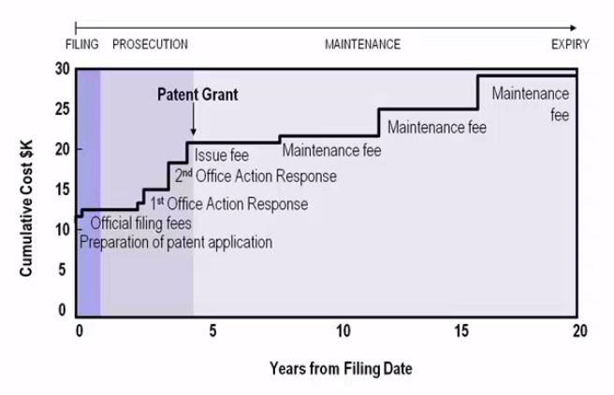

* Initial payment is ~$10K
* Initial fee goes to patent attorneys who draft it for you
  + There are lots of traps and pitfalls
  + You can draft it yourself but a professional might avoid those pitfalls
* Over the years you debate with the examiner (like the USPTO), every time this costs money
  + You also pay extension fees if you can’t meet a deadline
  + You may get a grant within 5 years
* Then you pay renewal fees (maintenance fees) regularly

## Example: US 5356330 (1994)

* The apparatus simulates a ‘high five’
* Is this worth the patent? Would a lot of people buy this? Not really so no
* Question: Would a 3D high five simulator conflict with this? Maybe because it “simulates” a high five so you’d have to word it right
  + It depends on the patent two, does it limit the mechanical construction of the thing? Or the virtual as well?

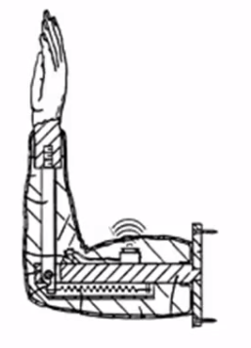

## Example: US 4022227 (1977)

* A method for concealing partial boldness

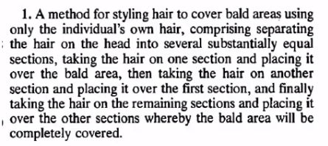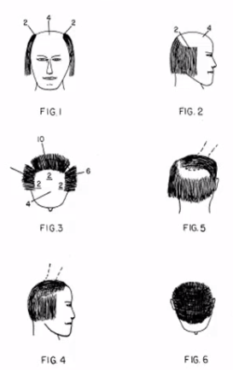

* How do you go after someone that breaches this? It would be an individual, but how do you go against one person doing this? It’s much easier against a company that sells a product and makes money from it

## Patent claim e.g. #1

* For banking encryption or something:

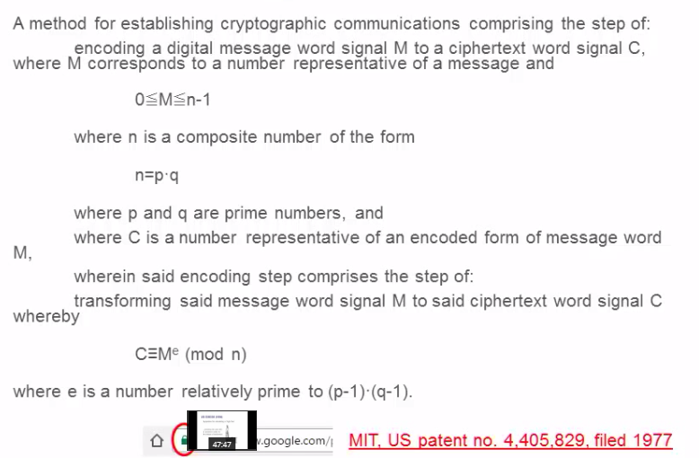

## Patent claim e.g. #2

* For MP3

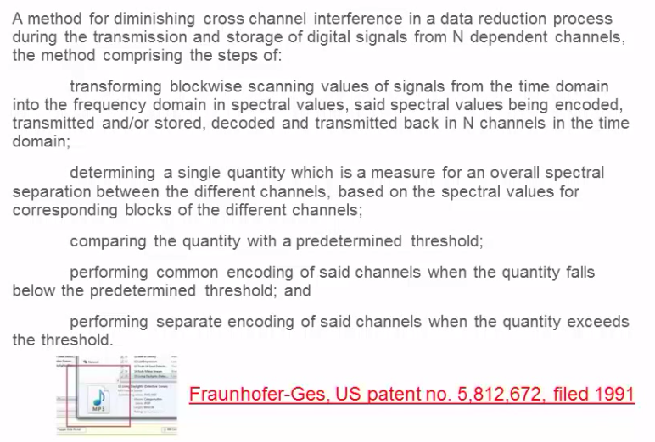

## Patent claim e.g. #3

* For wifi!:

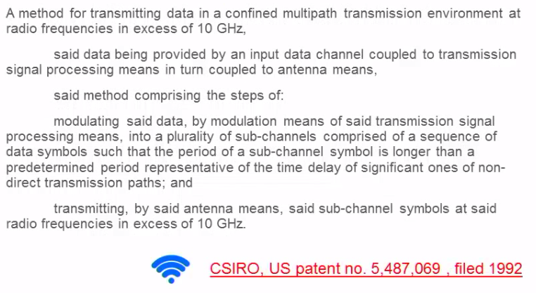

# Week 7: Agile ….

## Introduction

* We are an independent management and IT consultancy professional services practice
* Consultancy is about reimagining the possibilities to drive the change required
* It is the intersection between commercial acumen, creativity and technical know-how

# Week 8: